- Create a Python function sigmoid(x) that takes a numeric input and returns the sigmoid value using the formula 1 / (1 + exp(-x)). Test your function with x = -2, 0, and

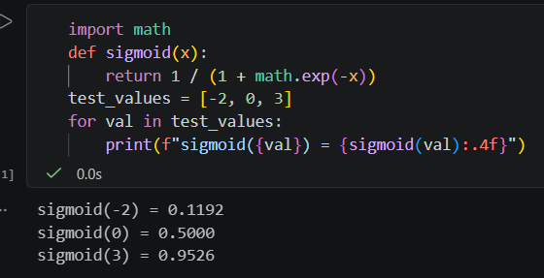

- Given a dataset of 10 Instagram posts with features 'likes' and 'has_caption' (1 if caption present, 0 if not), and a label 'viral' (1 if post went viral, 0 otherwise), write code to fit a logistic regression model to predict 'viral' using scikit-learn. Print the model coefficients.
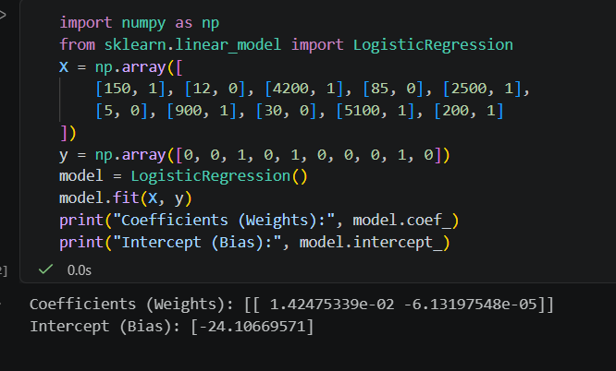

- Plot the sigmoid function for x values from -10 to 10 using matplotlib, and visually indicate the threshold at 0.5 on the plot. Use plt.axhline() to draw the threshold line.

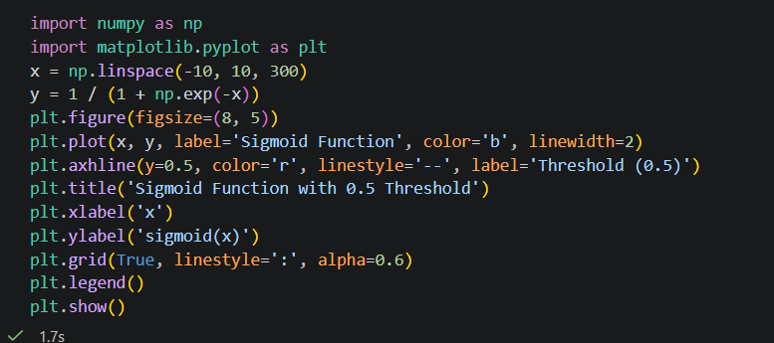

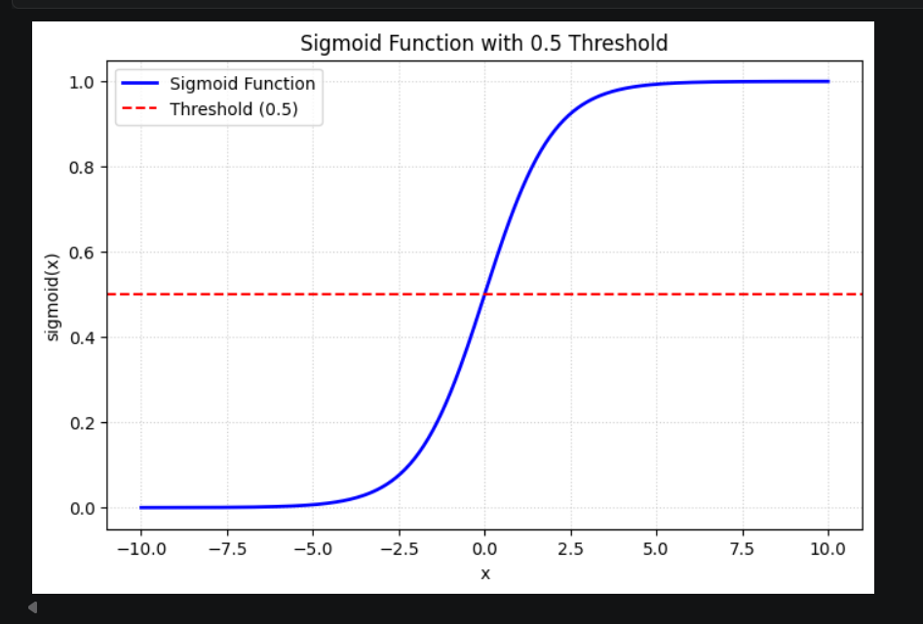

- Given a probability output from your logistic regression model, write a function that classifies the result as 'Viral' or 'Not Viral' based on a threshold value that you can set (default 0.5). Test your function with probabilities 0.2, 0.6, and 0.8 and thresholds 0.5 and 0.7.
